# 

# 

# ESBHA001

# Diagnostic Data Design Document

Version 0.2

**Document Control Data Sheet**

|  |  |
| --- | --- |
| **Document information** | |
| **Classification** | Confidential |
| **Document Name** | Diagnostic Data Design Document |
| **Document Issue No.** | 0 |
| **Document Revision No.** | 2 |
| **Document Id** | ATPL/SDS/24/01/2020-1 |
| **Document Issue date** | 24/01/2020 |
| **Prepared by** | Anoop M |
| **Reviewed By** | Rafi |
| **Approved By** |  |
| **Distribution List** | Alcodex project team |

**Document Amendment Sheet**

|  |  |  |  |  |  |  |
| --- | --- | --- | --- | --- | --- | --- |
| **Sl No** | **Issue /**  **Revision** | **Date** | **Change Description** | **Prepared**  **By** | **Reviewed**  **By** | **Approved**  **By** |
| 1 | 0.1 | 08-01-2020 | Initial draft | Anoop M | Rafi | NA |
| 2 | 0.2 | 23-01-2020 | Update against review comments | Anoop M | Rafi | NA |
|  |  |  |  |  |  |  |
|  |  |  |  |  |  |  |
|  |  |  |  |  |  |  |
|  |  |  |  |  |  |  |
|  |  |  |  |  |  |  |
|  |  |  |  |  |  |  |
|  |  |  |  |  |  |  |
|  |  |  |  |  |  |  |
|  |  |  |  |  |  |  |
|  |  |  |  |  |  |  |
|  |  |  |  |  |  |  |
|  |  |  |  |  |  |  |
|  |  |  |  |  |  |  |

**Design description**

There will be two types of error, that can happen in AQMS device,

1. Sensor Initialization error
2. Sensor Read error

So, we use a 32-bit data, to represent each error type

|  |  |  |
| --- | --- | --- |
| **Param name** | **Data type** | **Represents** |
| "er_init_sensor" | uint32_t | Sensor Initialization error |
| "er_read_sensor" | uint32_t | Sensor Read error |

Assign a specific bit to a specific sensor in 32-bit data.

|  |  |
| --- | --- |
| **Bit** | **Represents** |
| 0 | CHIPCAP2 Temperature |
| 1 | CHIPCAP2 Humidity |
| 2 | BMP180 Pressure |
| 3 | PMS5003 PM1 |
| 4 | PMS5003 PM2.5 |
| 5 | PMS5003 PM10 |
| 6 | MICS6814 NH3 |
| 7 | MICS6814 NO2 |
| 8 | MICS6814 CO |
| 9 | CM1106-C CO2 |
| 10 | DGS_SO2_20 SO2 |
| 11 | INMP401 Noise |
| 12 | ZE_25_O3 O3 |
| 13 | RG11 Rain |

**Data flow diagram**

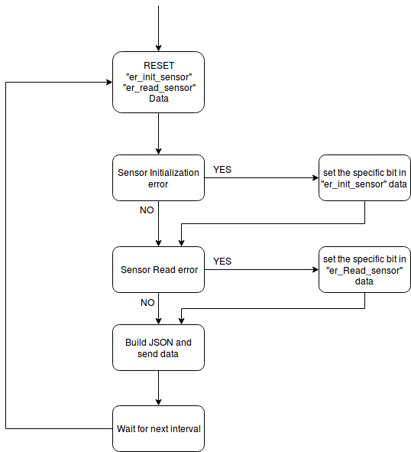

**JSON Data**

{

"deviceId":"Device ID",

"Data":

{

"temperature":Value,

"humidity":Value,

"pressure":Value,

"CO2":Value,

"PM2p5":Value,

"PM10":Value,

"PM1":Value,

"noise":Value,

"SO2":Value,

"NO2":Value,

"CO":Value,

"O3":Value,

"NH3":Value,

"rain":Value,

**"er_init_sensor":Value,**

**"er_read_sensor":Value**

}

}

**Example: -**

The error codes for ‘initialization error’ and ‘read error’ in Temperature and NO2 sensors are as follows:

**Initialization Error code** **= 0x0081 (**in Hex)

**Read Error code**  **= 0x0081** (in Hex)

Note: - **0x0081 ::** 0000 0000 1000 0001 (in binary) ,129 (in decimal)